Ross Nelson / GSFC, Code 618 November 21, 2011
Regression results, Howard County and Anne Arundel County:

All cover types (nonstratified):
[.\CMS\Sept2011_regression_analysis\ HoCo_AACo_allcts_112111.sas]

Best linear model: R² = 0.619
R²_{adj} = 0.616
Biomass = -21.225 + 3.135(h95) + 1.832(cc) RMSE = 79.837
p<0.0003 p<0.0001 VIF = 4.38
n = 293
Note: best 3-var. model VIFs > 25, not used.

Cross Validation: R²_{biom_pred vs biom} = 0.61
RMSE = sqrt(6437.65) = 80.23 t/ha

Training/Test: R² = 0.67
R²_{adj} = 0.67
Biomass = -25.938 + 5.267(h95) + 1.243(cc) RMSE = 72.35
VIF = 4.12
n = 147
Test data results: estimated using training equation.
R²_{pred vs biom} = 0.56
RMSE_{pred – biom} = sqrt(7771.44) = 88.16 t/ha
n = 146
Prediction Interval: prediction interval around a new observation – 95% level of confidence around the best linear model:
(X’X)⁻¹ matrix:
Variable Intercept h95 cc
Intercept 0.0123234116 -0.000280138 -0.000066583
H95 -0.000280138 0.0001140637 -0.000030779
cc -0.000066583 -0.000030779 0.000010764

Equation to predict 95% confidence limit around a new observation:
predicted biomass ± (t_{α/2,n-p}) (RMSE) $\sqrt{1 + x_{0}^{'}(X'X)^{−1}x_{0}}$
where predicted biomass = from best linear model,
t_{0.025, 300-3} = 1.96,
RMSE = from best linear model = 79.837,
and $\sqrt{1 + x_{0}^{'}(X'X)^{−1}x_{0}}$ is as follows:

sqrt[1 + (0.0123234116 + (-0.000280138)(h95) + (-0.000066583)(cc))
+ (-0.000280138 + (0.0001140637)(h95) + (-0.000030779)(cc))*h95
+ (-0.000066583 + (-0.000030779)(h95) + (0.000010764)(cc))*cc]
Note : to generate map of size of prediction interval only (without tying it to the actual biomass prediction), calculate only the (t_{α/2,n-p}) (RMSE) $\sqrt{1 + x_{0}^{'}(X'X)^{−1}x_{0}}$ portion.
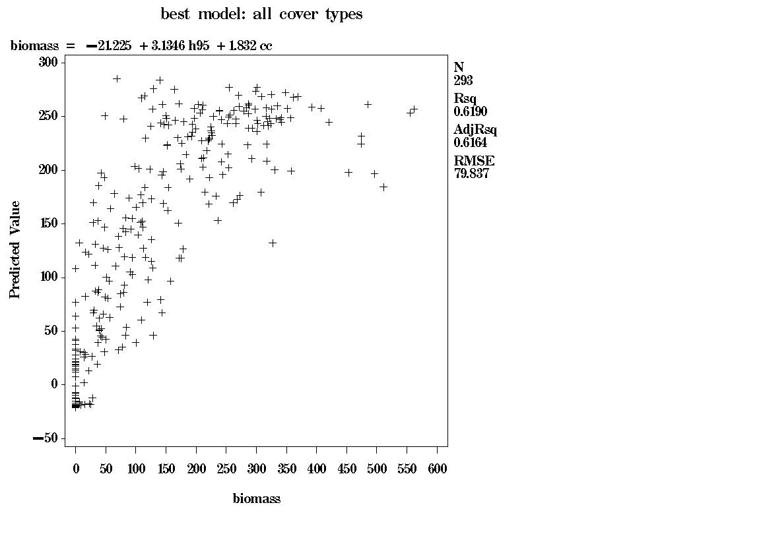
Figure 1. Howard and Anne Arundel County biomass estimates for all cover types,
ground-measured biomass (X, in Mg ha⁻¹) versus predicted biomass (Y, in Mg ha⁻¹).

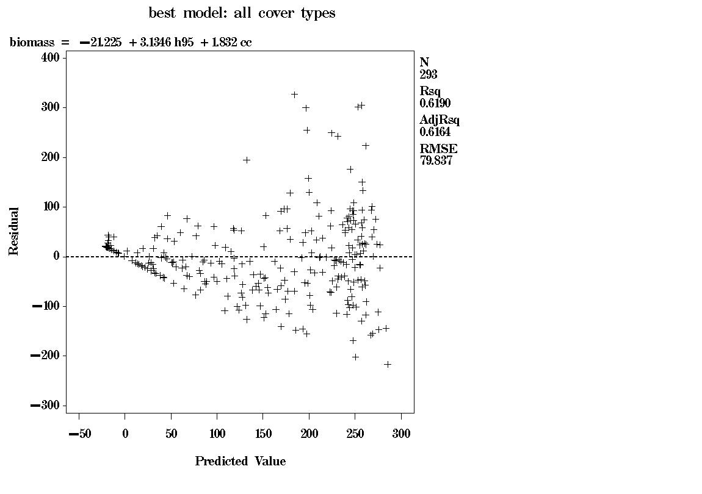
Figure 2. Howard and Anne Arundel Counties, all cover types, predicted aboveground
dry biomass (X, in Mg ha⁻¹) versus biomass residual (Y, in Mg ha⁻¹).

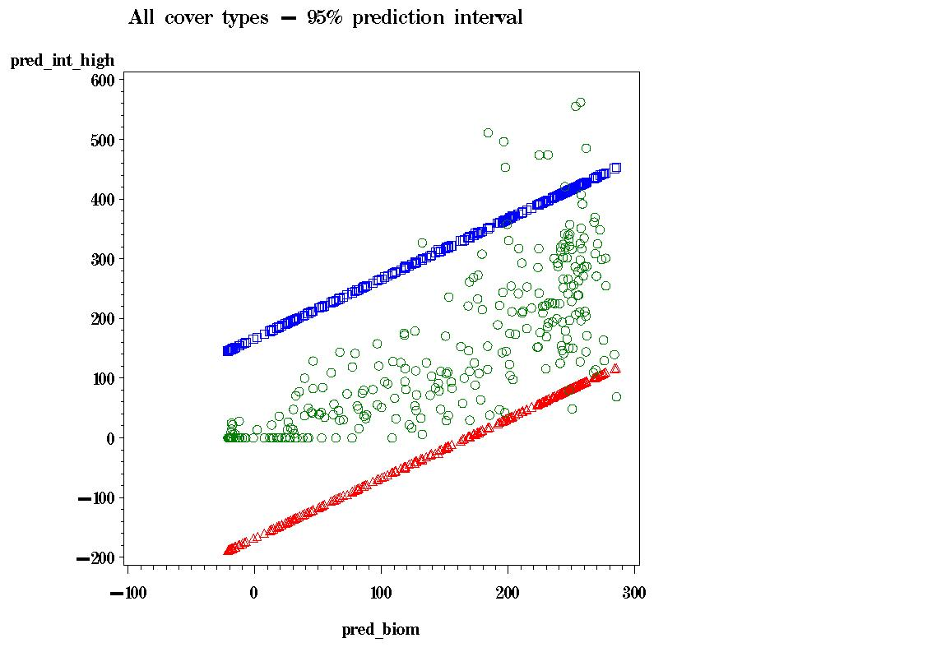
Figure 3. Howard and Anne Arundel Counties, all cover types, 95% prediction interval
around ground-measured biomass (green circles). Red triangles – lower bound. Blue
squares – upper bound. The units on both axes are Mg ha⁻¹.

Hardwood Equation:
[.\CMS\Sept2011_regression_analysis\ HoCo_AACo_hardwd_112111.sas]

Best linear model: R² = 0.512
R²_{adj} = 0.488
Biomass = -3.611 + 3.078(h95) – 1.219(d55) +2.601(cc) RMSE = 98.778
p<0.193 p<0.532 p<0.014 VIF = 7.56
n = 65
Note: best 2-var. model had large intercept positive or negative intercept terms.

Cross Validation: R²_{biom_pred vs biom} = 0.45
RMSE = sqrt(10427.49) = 102.12 t/ha

Training/Test: R² = 0.51
R²_{adj} = 0.46
Biomass = 37.289 + 5.739(h95) – 2.168(d55) +2.084(cc) RMSE = 99.09
VIF = 5.42
n = 33
Test data results: estimated using training equation,
R²_{pred vs biom} = 0.49
RMSE_{pred – biom} = sqrt(10581.50) = 102.87 t/ha
n = 32
Prediction Interval: prediction interval around a new observation – 95% level of confidence around the best linear model:
(X’X)⁻¹ matrix:
Variable Intercept h95 d55 cc
Intercept 0.263989237 0.0009246777 -0.008463715 0.0024264854
h95 0.0009246777 0.0005597175 -0.000088719 -0.000121928
d55 -0.008463715 -0.000088719 0.0003849477 -0.000139537
cc 0.0024264854 -0.000121928 -0.000139537 0.0001090312

Equation to predict 95% confidence limit around a new observation:
predicted biomass ± (t_{α/2,n-p}) (RMSE) $\sqrt{1 + x_{0}^{'}(X'X)^{−1}x_{0}}$
where predicted biomass = from best linear model,
t_{0.025, 68-3} = 1.96,
RMSE = from best linear model = 98.778,
and $\sqrt{1 + x_{0}^{'}(X'X)^{−1}x_{0}}$ is as follows:

sqrt[ 1 + (0.263989237+ (0.0009246777)(h95) + (-0.008463715)(d55) + (0.0024264854)(cc))
+ (0.0009246777+ (0.0005597175)(h95) + (-0.000088719)(d55) + (-0.000121928)(cc))*h95
+ (-0.008463715+ (-0.000088719)(h95) + (0.0003849477)(d55) + (-0.000139537)(cc))*d55
+ (0.0024264854+ (-0.000121928)(h95) + (-0.000139537)(d55) + (0.0001090312)(cc))*cc ]

Note : to generate map of size of prediction interval only (without tying it to the actual biomass prediction), calculate only the (t_{α/2,n-p}) (RMSE) $\sqrt{1 + x_{0}^{'}(X'X)^{−1}x_{0}}$ portion.
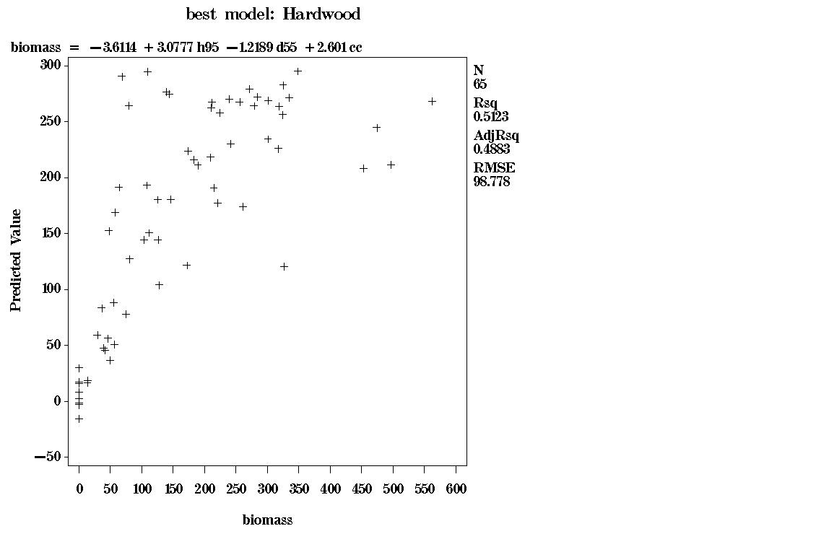
Figure 4. Howard and Anne Arundel County biomass estimates for hardwoods,
ground-measured biomass (X, in Mg ha⁻¹) versus predicted biomass (Y, in Mg ha⁻¹).
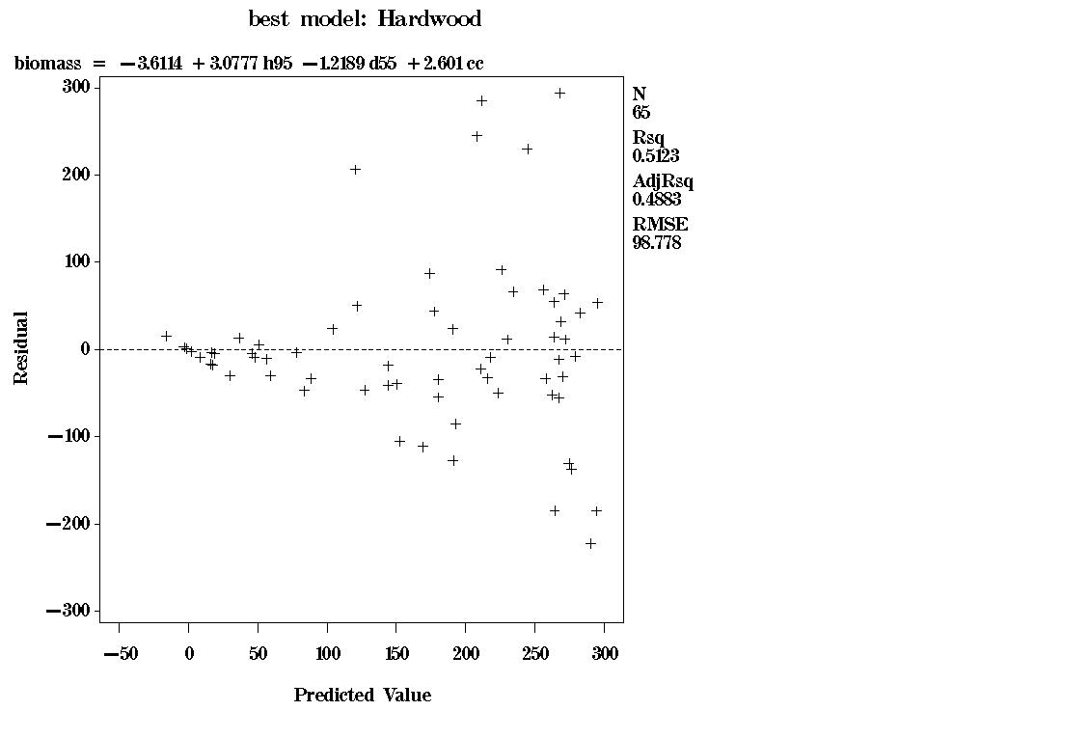
Figure 5. Howard and Anne Arundel Counties, hardwoods, predicted aboveground
dry biomass (X, in Mg ha⁻¹) versus biomass residual (Y, in Mg ha⁻¹).

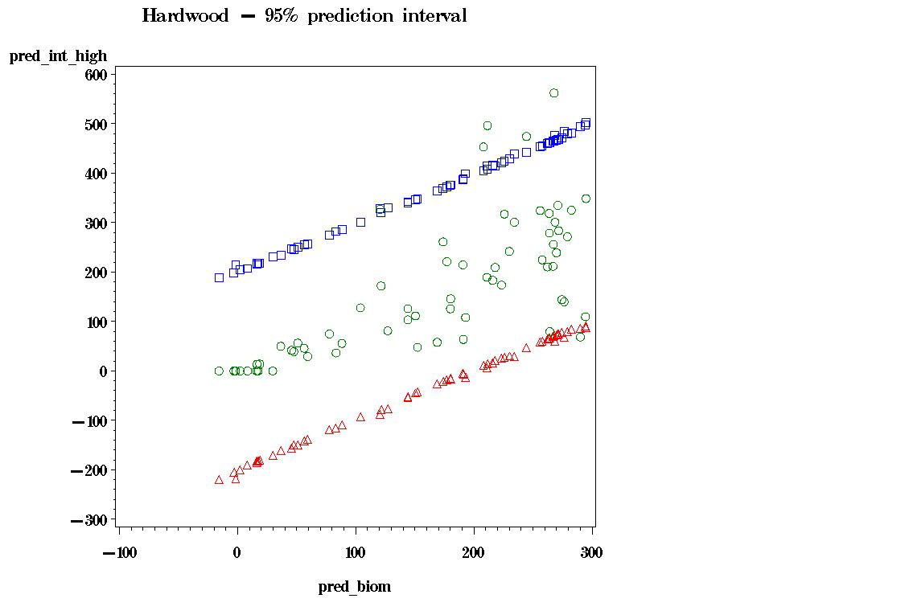
Figure 6. Howard and Anne Arundel Counties, hardwoods, 95% prediction interval
around ground-measured biomass (green circles). Red triangles – lower bound. Blue
squares – upper bound. The units on both axes are Mg ha⁻¹.
Mixedwood Equation:
[.\CMS\Sept2011_regression_analysis\ HoCo_AACo_mixed_112111.sas]

Best linear model: R² = 0.498
R²_{adj} = 0.481
Biomass = -13.197 + 2.137(qmha) + 2.278(cc) RMSE = 95.198
p<0.442 p<0.002 VIF = 4.06
n = 64
Note: best 3-var. model VIFs > 35; not used.

Cross Validation: R²_{biom_pred vs biom} = 0.46
RMSE = sqrt(9353.75) = 96.71 t/ha

Training/Test: R² = 0.59
R²_{adj} = 0.56
Biomass = -13.513 + 2.405(qmha) + 1.875(cc) RMSE = 70.99
VIF = 3.61
n = 32
Test data results: estimated using training equation,
R²_{pred vs biom} = 0.50
RMSE_{pred – biom} = sqrt(14030.64) = 118.45 t/ha
n = 32
Prediction Interval: prediction interval around a new observation – 95% level of confidence around the best linear model:

(X’X)⁻¹ matrix:
Variable Intercept qmha cc
Intercept 0.0778364246 0.0015009992 -0.001256037
qmha 0.0015009992 0.0008396364 -0.000190437
cc -0.001256037 -0.000190437 0.0000572755

Equation to predict 95% confidence limit around a new observation:
predicted biomass ± (t_{α/2,n-p}) (RMSE) $\sqrt{1 + x_{0}^{'}(X'X)^{−1}x_{0}}$
where predicted biomass = from best linear model,
t_{0.025, 66-3} = 1.96,
RMSE = from best linear model = 95.198,
and $\sqrt{1 + x_{0}^{'}(X'X)^{−1}x_{0}}$ is as follows:

sqrt[1 + (0.0778364246 + (0.0015009992)(qmha) + (-0.001256037)(cc))
+ (0.0015009992 + (0.0008396364)(qmha) + (-0.000190437)(cc))*qmha
+ (-0.001256037+ (-0.000190437)(qmha) + (0.0000572755)(cc))*cc]

Note : to generate map of size of prediction interval only (without tying it to the actual biomass prediction), calculate only the (t_{α/2,n-p}) (RMSE) $\sqrt{1 + x_{0}^{'}(X'X)^{−1}x_{0}}$ portion.
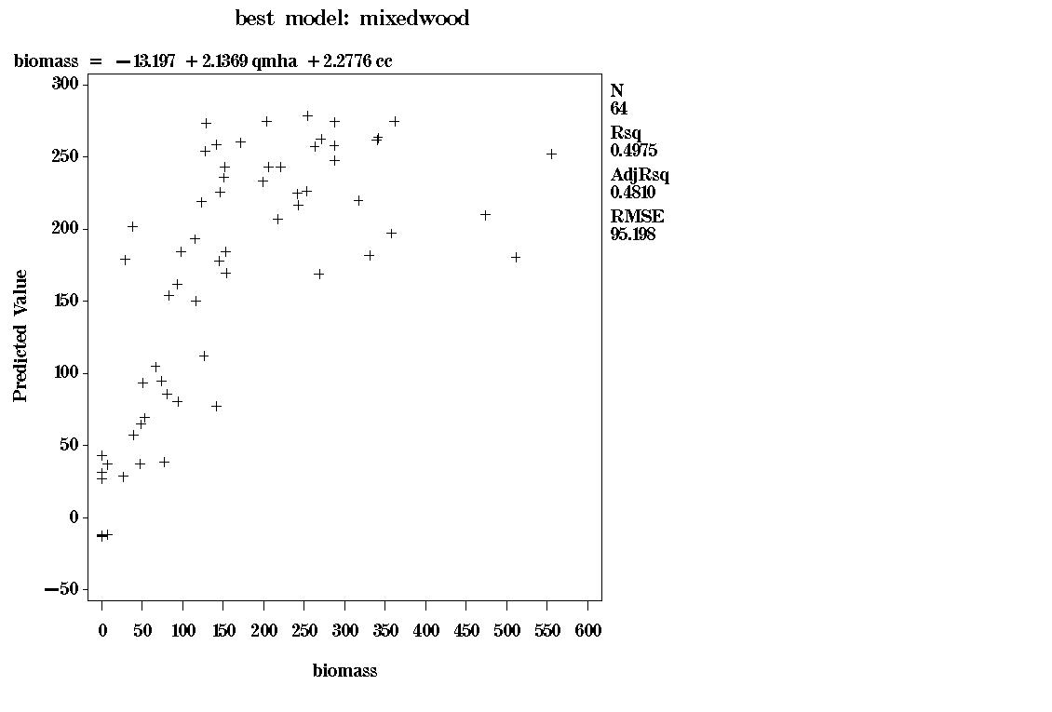
Figure 7. Howard and Anne Arundel County biomass estimates for mixedwoods,
ground-measured biomass (X, in Mg ha⁻¹) versus predicted biomass (Y, in Mg ha⁻¹).

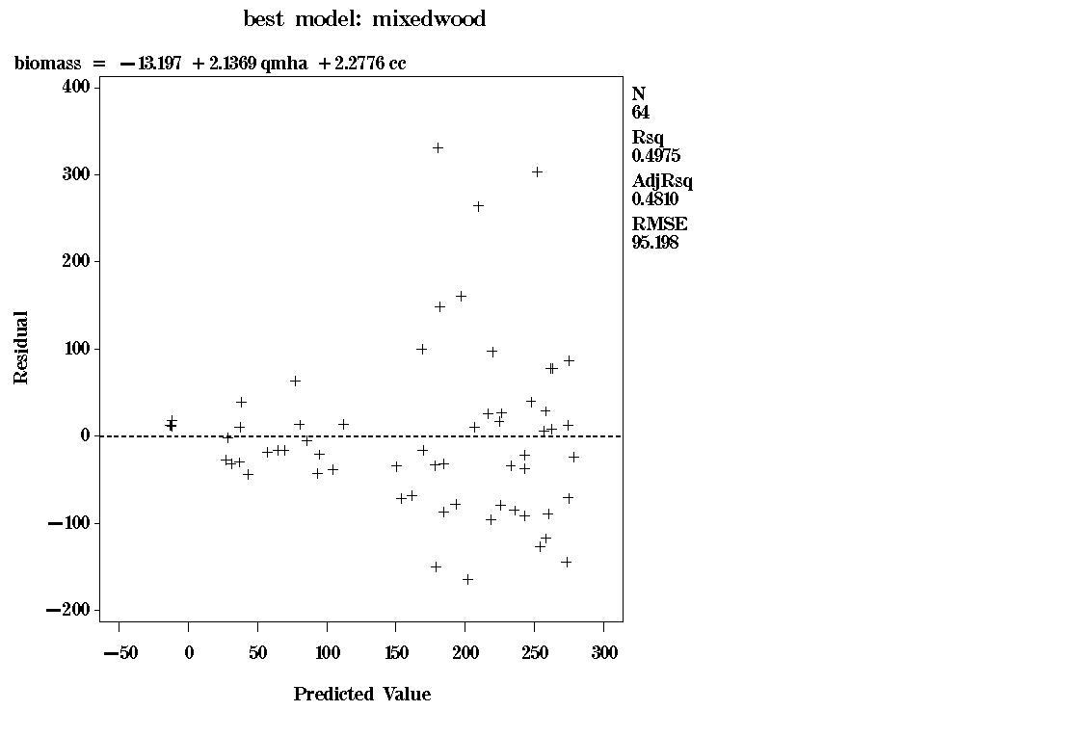
Figure 8. Howard and Anne Arundel Counties, mixedwoods, predicted aboveground
dry biomass (X, in Mg ha⁻¹) versus biomass residual (Y, in Mg ha⁻¹).
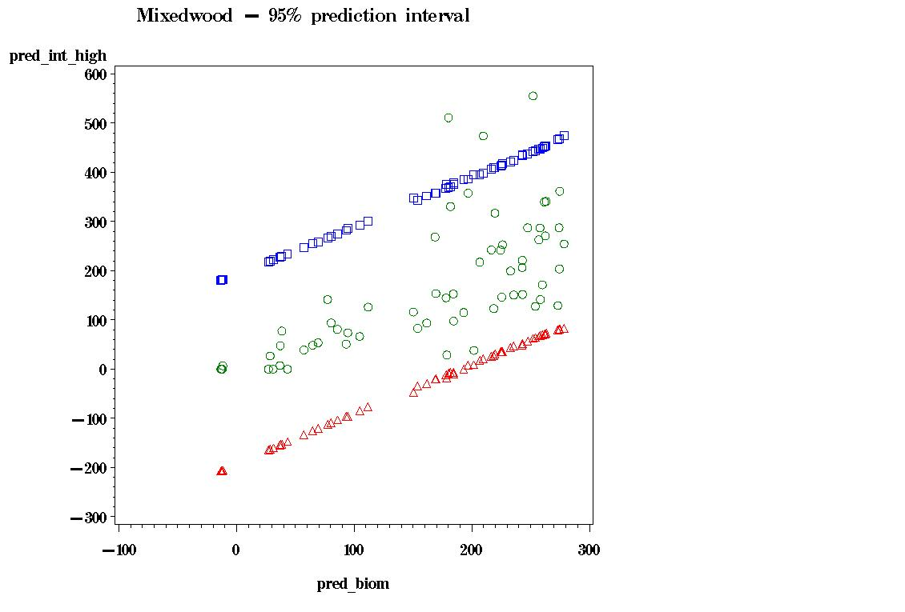
Figure 9. Howard and Anne Arundel Counties, mixedwoods, 95% prediction interval
around ground-measured biomass (green circles). Red triangles – lower bound. Blue
squares – upper bound. The units on both axes are Mg ha⁻¹.

Conifer Equation:
[.\CMS\Sept2011_regression_analysis\ HoCo_AACo_con_112111.sas]

Best linear model: R² = 0.592
R²_{adj} = 0.578
Biomass = -1.064 + 8.145(h40) + 1.299(d30) RMSE = 78.400
p<0.0001 p<0.091 VIF = 2.29
n = 59
Note: best 3-var. model VIFs > 49; minimal increases in R², minimal decrease in RMSEs.

Cross Validation: R²_{biom_pred vs biom} = 0.56
RMSE = sqrt(6348.13) = 79.68 t/ha

Training/Test: R² = 0.48
R²_{adj} = 0.44
Biomass = -7.287 + 5.545(h40) + 1.569(d30) RMSE = 83.08
VIF = 2.86
n = 30
Test data results: estimated using training equation,
R²_{pred vs biom} = 0.71
RMSE_{pred – biom} = sqrt(6611.57) = 81.31 t/ha
n = 29
Prediction Interval: prediction interval around a new observation – 95% level of confidence around the best linear model:
(X’X)⁻¹ matrix:
Variable Intercept h40 d30
Intercept 0.2505902485 0.0055212529 -0.004411311
h40 0.0055212529 0.0005195001 -0.000164649
d30 -0.004411311 -0.000164649 0.0000926674

Equation to predict 95% confidence limit around a new observation:
predicted biomass ± (t_{α/2,n-p}) (RMSE) $\sqrt{1 + x_{0}^{'}(X'X)^{−1}x_{0}}$
where predicted biomass = from best linear model,
t_{0.025, 62-3} = 1.96,
RMSE = from best linear model = 78.400,
and $\sqrt{1 + x_{0}^{'}(X'X)^{−1}x_{0}}$ is as follows:

sqrt[1 + (0.2505902485 + (0.0055212529)(h40) + (-0.004411311)(d30))
+ (0.0055212529 + (0.0005195001)(h40) + (-0.000164649)(d30))*h40
+ (-0.004411311+ (-0.000164649)(h40) + (0.0000926674)(d30))*d30]

Note : to generate map of size of prediction interval only (without tying it to the actual biomass prediction), calculate only the (t_{α/2,n-p}) (RMSE) $\sqrt{1 + x_{0}^{'}(X'X)^{−1}x_{0}}$ portion.
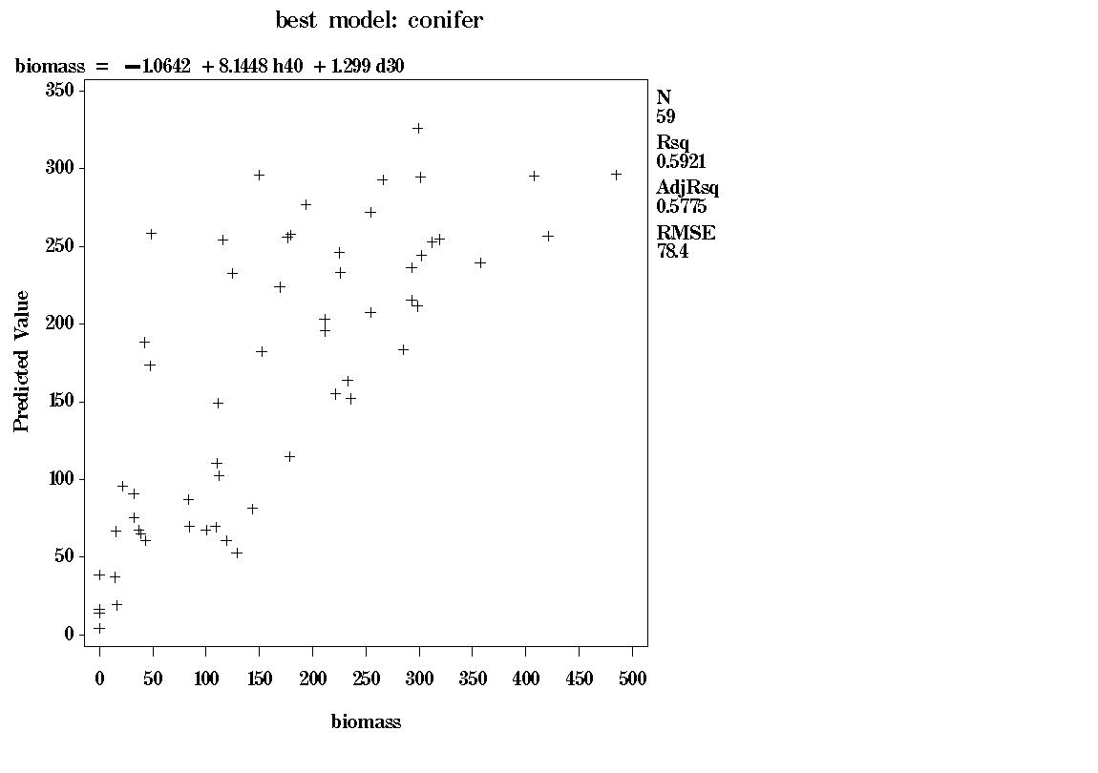
Figure 10. Howard and Anne Arundel County biomass estimates for conifers,
ground-measured biomass (X, in Mg ha⁻¹) versus predicted biomass (Y, in Mg ha⁻¹).

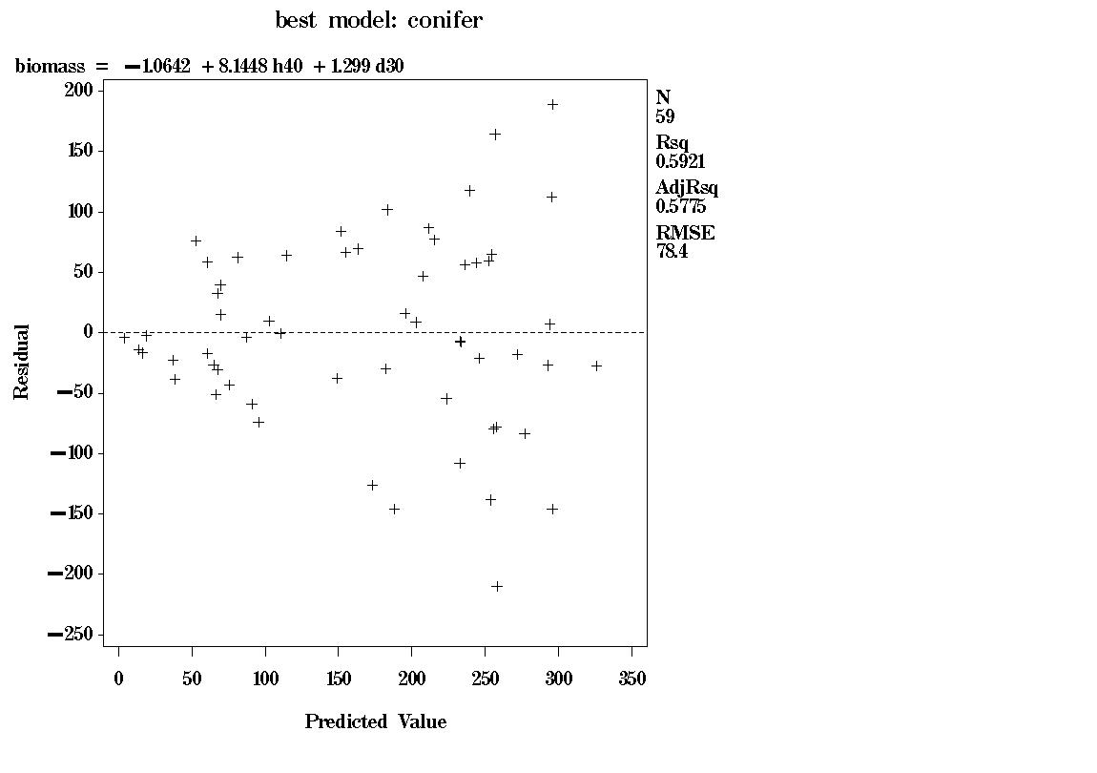
Figure 11. Howard and Anne Arundel Counties, conifers, predicted aboveground
dry biomass (X, in Mg ha⁻¹) versus biomass residual (Y, in Mg ha⁻¹).
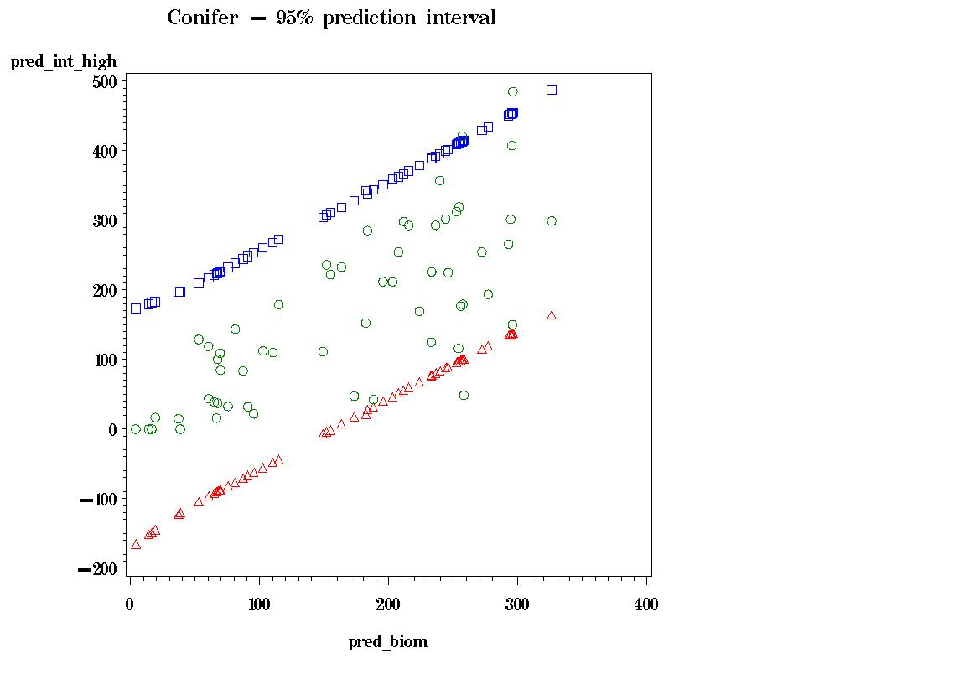
Figure 12. Howard and Anne Arundel Counties, conifers, 95% prediction interval
around ground-measured biomass (green circles). Red triangles – lower bound. Blue
squares – upper bound. The units on both axes are Mg ha⁻¹.

Wetlands Equation:
[.\CMS\Sept2011_regression_analysis\ HoCo_AACo_wetland_112111.sas]

Best linear model: R² = 0.667
R²_{adj} = 0.652
Biomass = -19.866 + 8.428(hta) + 0.976(d15) RMSE = 70.294
p<0.0001 p<0.100 VIF = 2.46
n = 48
Note: best 3-var. model VIFs > 60; minimal increases in R², minimal decrease in RMSEs.

Cross Validation: R²_{biom_pred vs biom} = 0.62
RMSE = sqrt(5267.41) = 72.58 t/ha

Training/Test: R² = 0.68
R²_{adj} = 0.65
Biomass = -24.305 + 8.738(hta) + 1.046(d15) RMSE = 67.80
VIF = 2.29
n = 24
Test data results: estimated using training equation,
R²_{pred vs biom} = 0.65
RMSE_{pred – biom} = sqrt(5969.31) = 77.26 t/ha

Prediction Interval: prediction interval around a new observation – 95% level of confidence around the best linear model:
(X’X)⁻¹ matrix :
Variable Intercept hta d15
Intercept 0.1938637891 0.0026960818 -0.00279001
hta 0.0026960818 0.0006608674 -0.000163653
d15 -0.00279001 -0.000163653 0.0000683257

Equation to predict 95% confidence limit around a new observation:
predicted biomass ± (t_{α/2,n-p}) (RMSE) $\sqrt{1 + x_{0}^{'}(X'X)^{−1}x_{0}}$
where predicted biomass = from best linear model,
t_{0.025,47-3} = 1.96,
RMSE = from best linear model = 70.294,
and $\sqrt{1 + x_{0}^{'}(X'X)^{−1}x_{0}}$ is as follows:

sqrt[1 + (0.1938637891 + (0.0026960818)(hta) + (-0.00279001)(d15))
+ (0.0026960818 + (0.0006608674)(hta) + (-0.000163653)(d15))*hta
+ (-0.00279001+ (-0.000163653)(hta) + (0.0000683257)(d15))*d15]

Note : to generate map of size of prediction interval only (without tying it to the actual biomass prediction), calculate only the (t_{α/2,n-p}) (RMSE) $\sqrt{1 + x_{0}^{'}(X'X)^{−1}x_{0}}$ portion.
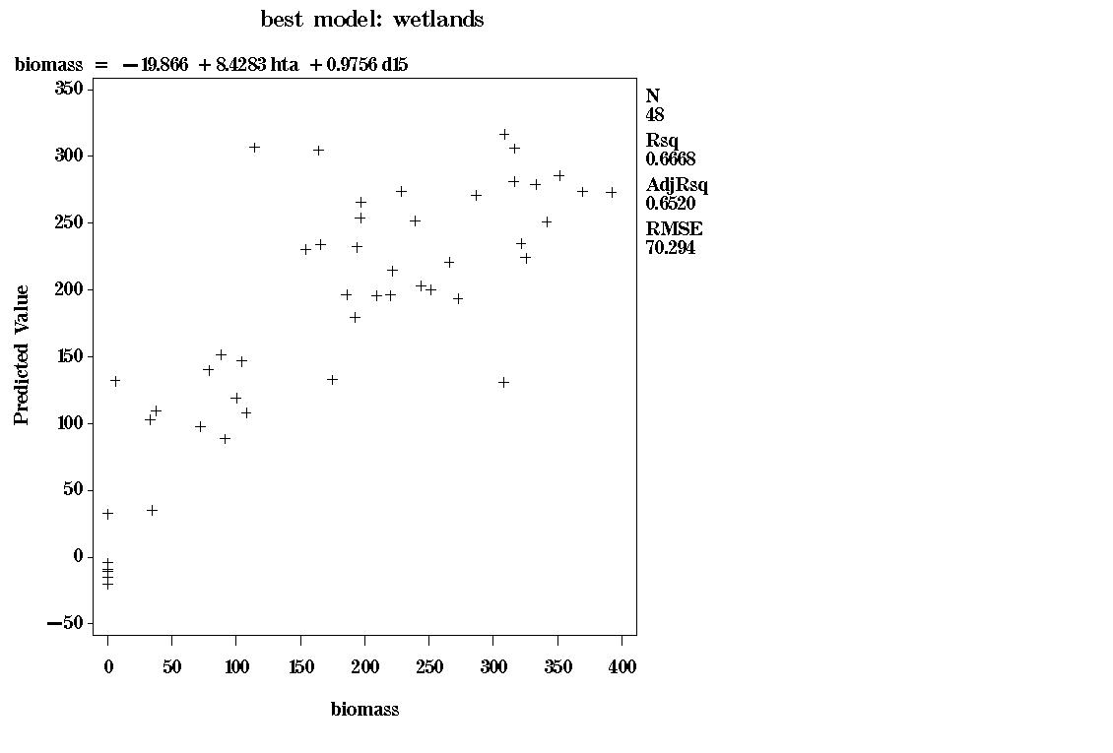
Figure 13. Howard and Anne Arundel County biomass estimates for wetlands,
ground-measured biomass (X, in Mg ha⁻¹) versus predicted biomass (Y, in Mg ha⁻¹).

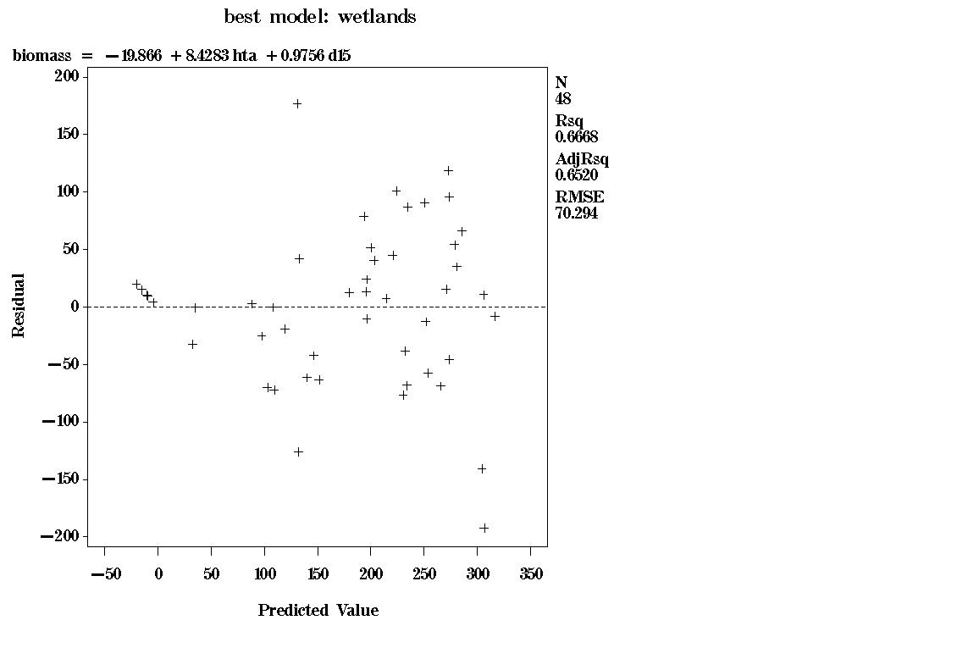
Figure 14. Howard and Anne Arundel Counties, wetlands, predicted aboveground
dry biomass (X, in Mg ha⁻¹) versus biomass residual (Y, in Mg ha⁻¹).

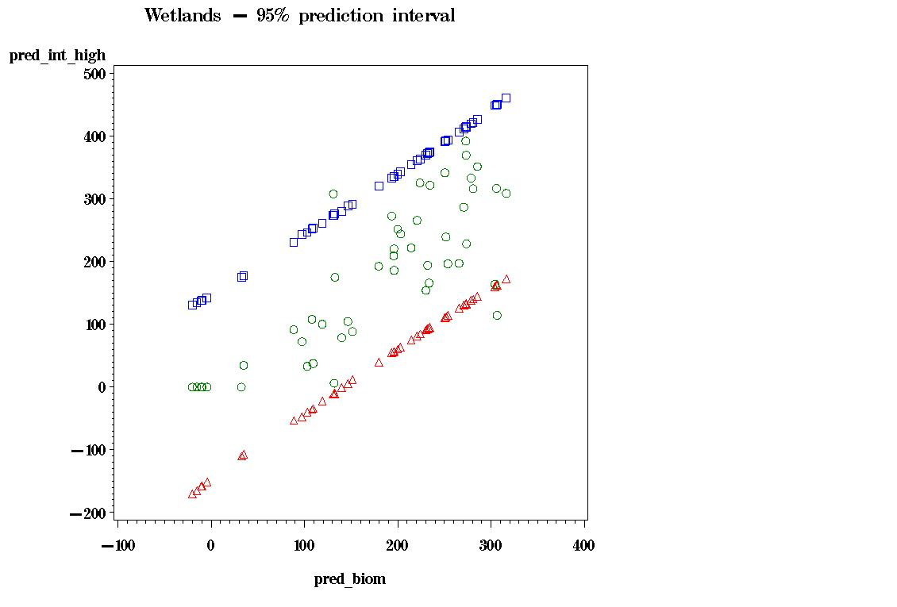
Figure 15. Howard and Anne Arundel Counties, wetlands, 95% prediction interval
around ground-measured biomass (green circles). Red triangles – lower bound. Blue
squares – upper bound. The units on both axes are Mg ha⁻¹.

Nonforest Equation:
[.\CMS\Sept2011_regression_analysis\ HoCo_AACo_nonforest_112111.sas]

Best linear model: R² = 0.568
R²_{adj} = 0.552
Biomass = 1.079 – 49.698(h05) + 5.567(h85) RMSE = 31.679
p<0.056 p<0.0001 VIF = 1.04
n = 57

Cross Validation: R²_{biom_pred vs biom} = 0.52
RMSE = sqrt(1070.05) = 32.71 t/ha

Training/Test: R² = 0.65
R²_{adj} = 0.62
Biomass = 0.468 – 26.328(h05) + 5.375(h85) RMSE = 26.87
VIF = 1.00
n = 29
Test data results: estimated using training equation,
R²_{pred vs biom} = 0.51
RMSE_{pred – biom} = sqrt(1320.14) = 36.33 t/ha
n = 28
Prediction Interval: prediction interval around a new observation – 95% level of confidence around the best linear model:
(X’X)⁻¹ matrix :
Variable Intercept h05 h85
Intercept 0.02887514 0.0241734621 -0.002164636
h05 0.0241734621 0.6441439309 0.0035919038
h85 -0.002164636 0.0035919038 0.0005272573
Equation to predict 95% confidence limit around a new observation:
predicted biomass ± (t_{α/2,n-p}) (RMSE) $\sqrt{1 + x_{0}^{'}(X'X)^{−1}x_{0}}$
where predicted biomass = from best linear model,
t_{0.025,57-3} = 1.96,
RMSE = from best linear model = 31.679,
and $\sqrt{1 + x_{0}^{'}(X'X)^{−1}x_{0}}$ is as follows:

sqrt[1 + (0.02887514 + (0.0241734621)(h05) + (-0.002164636)(h85))
+ (0.0241734621 + (0.6441439309)(h05) + (0.0035919038)(h85))*h05
+ (-0.002164636+ (0.0035919038)(h05) + (0.0005272573)(h85))*h85]

Note : to generate map of size of prediction interval only (without tying it to the actual biomass prediction), calculate only the (t_{α/2,n-p}) (RMSE) $\sqrt{1 + x_{0}^{'}(X'X)^{−1}x_{0}}$ portion.
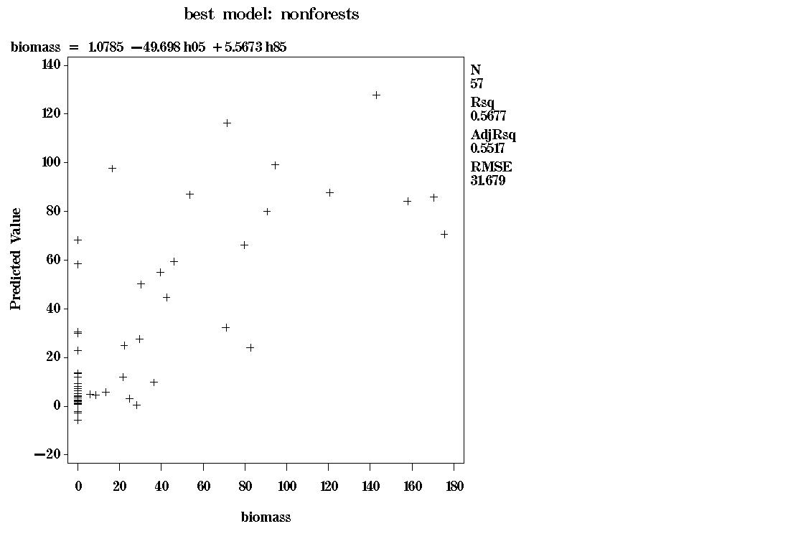
Figure 16. Howard and Anne Arundel County biomass estimates for nonforest,
ground-measured biomass (X, in Mg ha⁻¹) versus predicted biomass (Y, in Mg ha⁻¹).

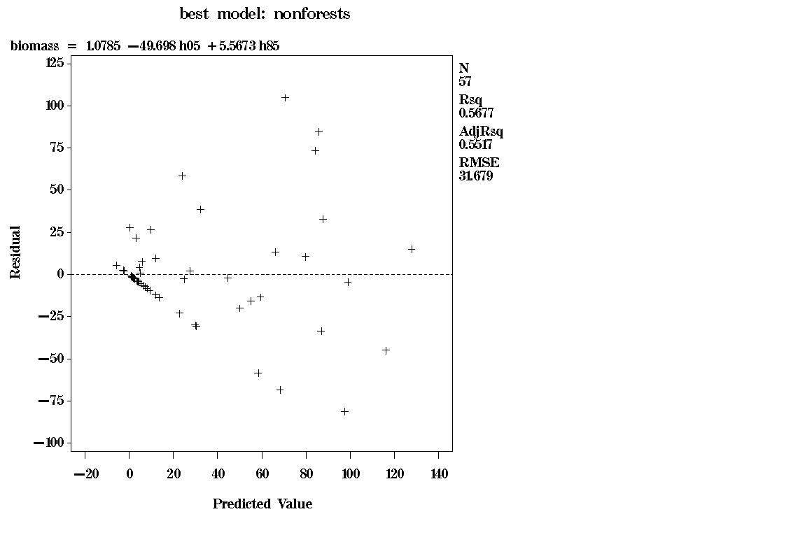
Figure 17. Howard and Anne Arundel Counties, nonforest, predicted aboveground
dry biomass (X, in Mg ha⁻¹) versus biomass residual (Y, in Mg ha⁻¹).

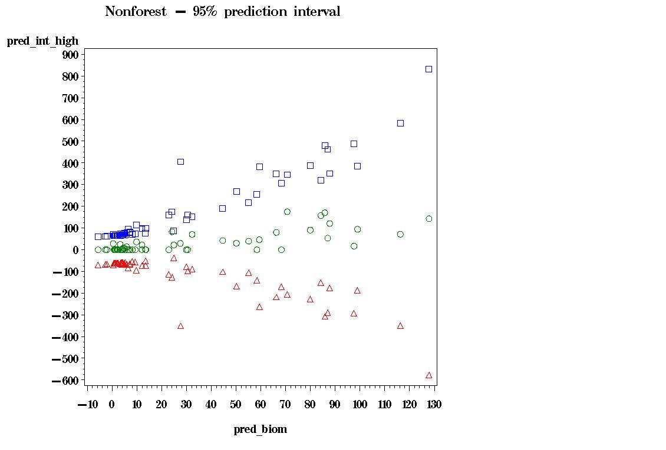
Figure 18. Howard and Anne Arundel Counties, nonforest, 95% prediction interval
around ground-measured biomass (green circles). Red triangles – lower bound. Blue
squares – upper bound. The units on both axes are Mg ha⁻¹.

